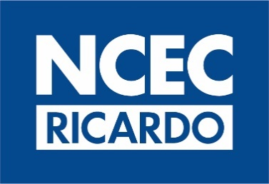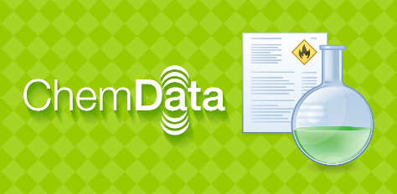

Chemdata Student Notes/Workbook
Chemdata release: 2023.1 (data), 2021.1 (program)

The aims of this training session are:
- To familiarise you with Chemdata searching
- To familiarise you with Chemdata document layout
- To familiarise you with how to customise Chemdata
- Provide you with some practical scenarios to test your Chemdata use
The trainer will show you Chemdata and highlight the different functionality and options available to you. This workbook provides a brief summary along with some screenshots to help you take notes. Also provided are a few scenarios to demonstrate how Chemdata will be beneficial to you and some exercises to help gain confidence in using Chemdata for yourself. If you do not have access to Chemdata yourself during the training session, we recommend you use the exercises to test your Chemdata knowledge as soon as possible afterwards.
Please note that there are differences in functionality between the standard Windows version of Chemdata and Pocket Chemdata (the database of substances is identical). Screenshots from Pocket Chemdata have been included where appropriate. If you normally use Chemdata on an MDT as part of a wider package provided by a Third Party, you may experience a different look and feel to Chemdata and some functionality may not have been made available by that developer.

How to refine a search when you have little information

Chemdata has been designed to help you search when you have only partial information on a substance, for example when you have damaged labels from wear and tear, water damage or fire damage. Keyword searching enable you to enter the partial words you can see just separate them by spaces. You can further narrow down your results by adding the UN number (if available) or a partial UN number using a wildcard (*) where there is missing text. You can also add information about the physical form, colour and appearance of the substance.

Exercise 1 You are responding to a leaking container. The label is damaged but, on the outside, you can see ‘copper’ and a symbol as shown below. There is an orange/brown liquid paste leaking from the container.
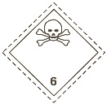How would you search Chemdata to identify this substance?

What is the substance?

Exercise 2 You are responding to an incident involving a drum of material with a damaged label as shown below
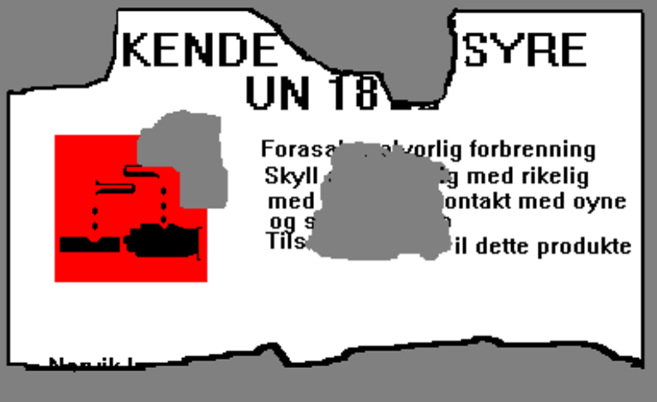

How would you search Chemdata to identify this substance?

What is the substance?

Searching Summary
When to use
“Full Name” + “Exact” -
“Full Name” + “Sounds Like” -
“Begins With” + “Exact” -
"Begins With” + “Sounds Like”-
“Keyword” + “Exact” -
“Keyword” + “Sounds Like” -

When can it be beneficial to add physical form, colour and appearance to the search criteria?

What is the Document number and when can it be beneficial to use it?

Short Questions

Q1 A small package labelled ‘Phostoxin’ has been discovered at the scene of an I.C.E incident.
What is the substance used for?
A – Fertiliser
B - Pesticide
C – Fungicide
D – Herbicide
What initial isolation distance would you recommend?
A – 0.1 km
B – 500 m
C – 30 m
D – 6.5 km

Q2 How many substances do you find that contain the partial name ‘Nickel ate’.
A – 69
B- 74
C – 479
D – 354
How many are a green liquid?
A – 6
B – 10
C – 4
D – 15
How many are a blue solid?
A - 45
B - 37
C - 23
D - 64

Q3 A drum has been found on an industrial site containing a colourless liquid which is gassing off. The name on the drum is partially obscured and reads as ‘odur’. What are the least number of hits you can achieve with the information provided?
A – 89
B – 134
C – 26
D - 21
You are later provided with a number 212-485-8. What is the chemical name for the product? (Pocket Chemdata users can’t currently carry out this search)
A – Hexamethylane diisocyanate
B – Hexamethylene diisocyanate
C - Hexanoic acid
D – Sodium diisocyanate

Q4 A ship is in the middle of the Atlantic and has a container on deck which is badly leaking hydrochloric acid (36%). Which Chemdata document number would you use?
A – 018020
B - 143696
C - 000214
D – 067052
Where might you search for advice in Chemdata which is specific to this situation?
A – Actions
B – Public Note
C – EMS Section
D – Private Note
Which gas may be liberated on contact with metal?
A - Hydrogen
B - Helium
C - Oxygen
D – Nitrogen

Scenario Questions
Exercise 1
You receive reports that a container of a chemical has fallen off a lorry and may have released its contents into the drains by the side of the road. The driver remembers that the substance is called 'DAA', but no other information is available at this stage. You are asked for advice on the hazards of the substance, precautions to take as it is suspected of having entered the drains and an Emergency Action Code. What advice do you offer? What information would you seek to help in offering your advice?

Exercise 2
A tanker has been involved in an accident at a junction. The Hazchem Placard has the following information:
EAC 2R
UN 1824
Company Tel No. 01928 572000
Which Chemdata document would you use to provide information to those at the scene?

What level of personal protection is recommended?

Who could you call for further assistance?

Exercise 3:
You receive a request for information on a substance called CRESOL, UN 2076. A drum of the substance has been found by the side of the road. The label on the drum says it is made by Bayer chemicals telephone number 01635 563000 but the label also has another number on it of 203-577-9.
Which Chemdata document could you use for advice in this situation?

What is the EAC for this substance, the level of protection required and the flash point of the substance (if it has one)?

